Tel: |  |  |  |  |  |  |  |  |  |  |  |  |  | 083 902 3001
Event Hiring Price List _{Email:}  Website: |  |  |  |  |  |  |  |  |  |  |  |  |  | MSTAAIBOSCH@gmail.co.za www.UMAMAFOODS.co.za
Tents & Marquee's - prices exclude Delivery
Product Image |  | Name |  | Price/Unit |  | Product Image |  | Name |  | Price/Unit |  | Product Image |  | Name |  | Price/Unit
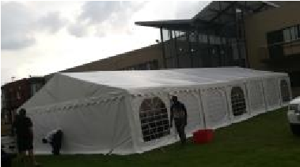 |  | 7x15m Frame Marquee |  | R6500 (including standard set-up) |  | 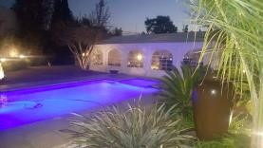 |  | 5x10m Frame Marquee |  | R3500 (including standard set-up |  | 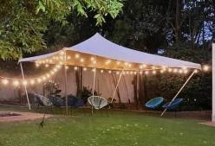 |  | 6x6m Waterproof Stretch tent - Beige |  | R2000 (standard grass set-up)
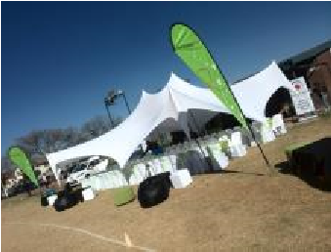 |  | 10x10m Décor water resistant stretch tent (not wind or fully waterproof) available in white |  | R1200 (excludes setup) |  | 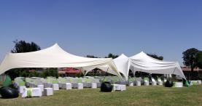 |  | 10x10m Décor water resistant stretch tent (not wind or fully waterproof) available in white |  | R1500 (excludes setup) |  | 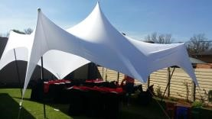 |  | 6x6m water resistant stretch tent (not wind or fully waterproof) available in white |  | R700 (excludes setup)
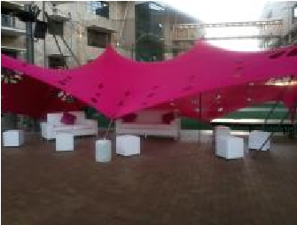 |  | 10x6m Décor stretch tent (not wind or waterproof) available in white, pink, yellow, blue |  | R1000 (excludes setup) |  |  |  | 10x10m Décor stretch tent (not wind or waterproof) available in white |  | R1200 (excludes setup) |  | 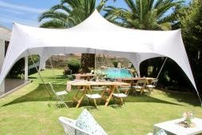 |  | 6x6m Décor stretch tent  (not wind or  waterproof) available in white & purple |  | R600 (excludes setup)
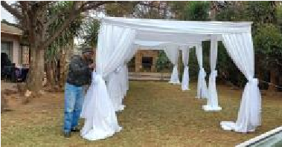 |  | 6x3m Cabana Tent (not waterproof) |  | R600 without draping or R900 with  (excludes set-up) |  | 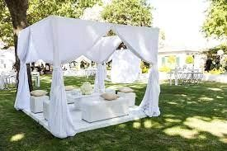 |  | 3x3m Cabana Tent (not  Waterproof) |  | R400 without draping or R550  with (excludes setup |  | 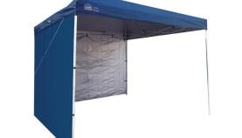 |  | 3x3m Pop-up Gazebo |  | R250 add sides for  R25/side
 |  |  |  |  |  |  | Lighting, Sound & Effects
 | Product Image |  | Name |  | Price/Unit |  | Product Image |  | Name |  | Price/Unit |  | Product Image |  | Name |  | Price/Unit
 | 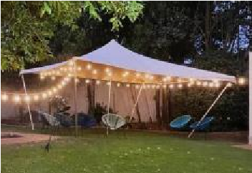 |  | 7m Globe lights (attachable for longer lengths) |  | R250 |  | 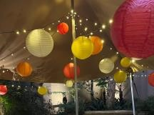 |  | 50m Fairy lights available in multi-color & warm white |  | R200 |  | 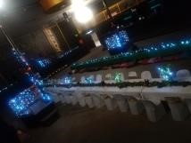 |  | 10m Electric Fairy lights, can be attached for longer lengths |  | R65
 | 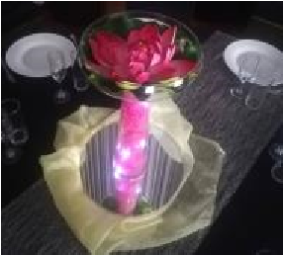 |  | Battery Operated fairy Lights (exclude batteries) warm white, cool white, blue & multicolor |  | 1-2m R8  3-5m R20  10m R40  20m R65 |  | 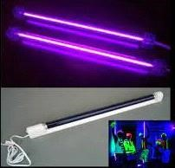 |  | UV Black light panels |  | R120 |  | 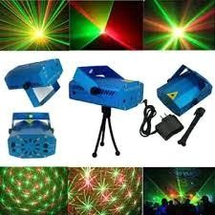 |  | Mini Laser Light |  | R65
 | 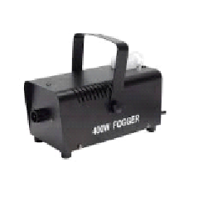 |  | Fog Machine |  | R100 (includes 1L fluid) |  | 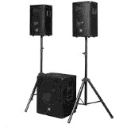 |  | PA System (includes wired mic) |  | R500 |  | 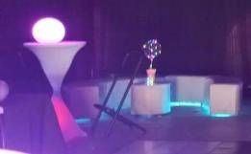 |  | Neon Flex strips 5m long |  | bR75

Draping, Backdrops, Plinths & Stands
Product Image | Name | Price/Unit | Product Image | Name | Price/Unit | Product Image | Name | Price/Unit
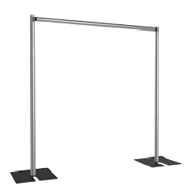 | Free standing poles, height adjustable to 3m | 2m R200  3m R250  R200 for every additional 3m extension | 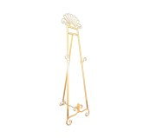 | Standing Easle available in gold and silver | R120 | 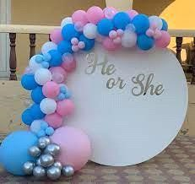 | Round Board | R300
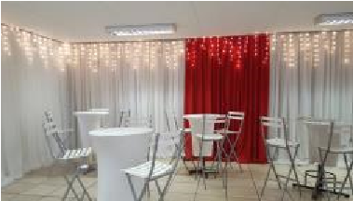 | Free standing drape backdrops with a standard hang, max height 3m | 3m R500  6m R900  9m R1200  bigger sizes available | 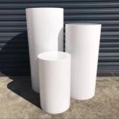 | Round Plinths (3 set) | R200 in black or  white  R100 additional for coloured covers | 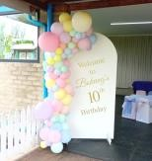 | Arch Board | R250
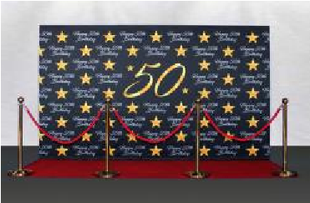 | Themed  Backdrop/photowalls  (prices exclude stands) | 2.25mx2.2.5m R1300  2.5mx3.7m R1500  3mx6m R2000 | 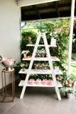 | A-Frame Shelf | R150 | 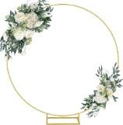 | Gold circle flower/balloon stand | R200
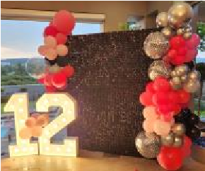 | Shimmer Walls 2m high x 1,8m wide black, gold & silver | R900 including stands | 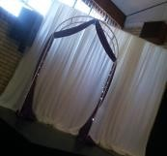 | White metal Arch | R250 (add draping for R100) | 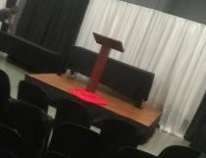 | Wooden podium | R80 (add draping for R70)
 |  |  | Bars, Carts, Carpets & Miscellaneous
Product Image | Name | Price/Unit | Product Image | Name | Price/Unit | Product Image | Name | Price/Unit
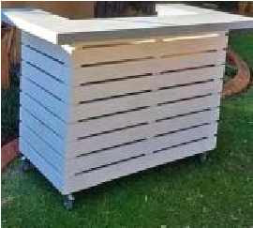 | White pallet Bar | R500 | 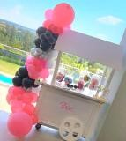 | Candy Cart | R450 | 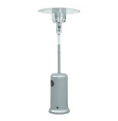 | Patio Heaters | R300  9L gas bottles quoted as per current gas
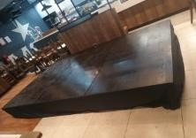 | Black platform  includes little stairs (requires a level surface) | 2.4mx2.4m R700  2.4mx3.6m R1000 | 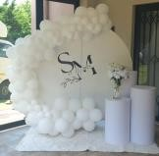 | Fluffy Rugs  1.5mx2m - white, pink, blue, black, rainbow | R100 | 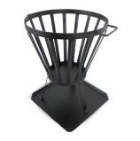 | Fire pits | R90
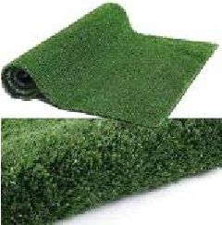 | Turf rolls, 2m in width | R150 - 6m roll  R200 - 9m roll | 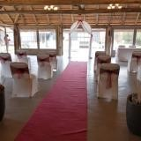 | Red Carpet Runner | 3m R200  5m R250  10m R350 | 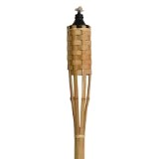 | Bamboo Torches  (own oil to be supplied) | R15
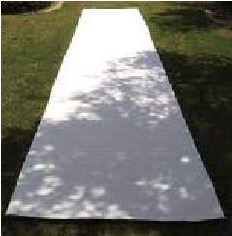 | White or Black carpet  Runner  8m long | R350 | 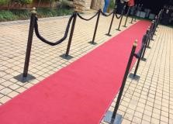 | Stanchions - Black | R65 (double stanchion with rope)  R45 for additional add-on's | 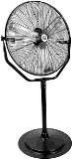 | Standing Fans | R200

 |  | Chairs, tables, cocktail & Lounges
Product Image | Name | Price/Unit | Product Image | Name | Price/Unit | Product Image | Name | Price/Unit
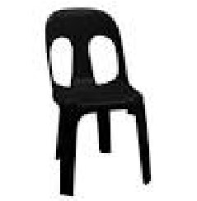 | Plastic Hola Chair | R7 | 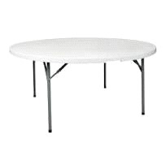 | Round table's  1800mm  1600mm  1500mm | R80 (10-12 seats)  R65 (8-10 seats)  R50 (6-8seats) | 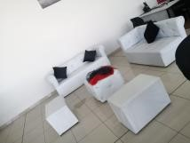 | Lounge Pod 9 seater  includes coffee table | R1 500
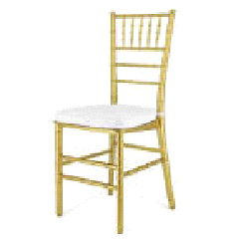 | Tiffany Chairs  Gold  Includes cushions | R35 | 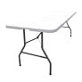 | Rectangle table's  1800mmx750mm  6-8 seater | R40 | 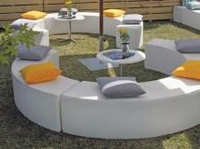 | Ottoman Set 8 seater includes side table | R400
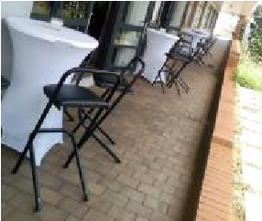 | Bar stools black padded | R35 | 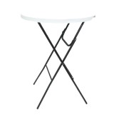 | Cocktail Tables  800cm diameter | R60 | 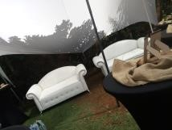 | 2 Seater Couch | R500
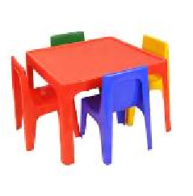 | Kids Jolly chairs  Kids Jolly Tables | R5  R15 | 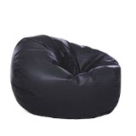 | Bean Bags - Black | R80 | 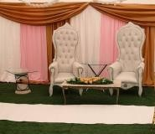 | Royal High Back Chair | R300
 |  | Linens, Cushions, Napkins (to be returned clean or a wash-up fee can be added)
Product Image | Name | Price/Unit | Product Image | Name | Price/Unit | Product Image | Name | Price/Unit
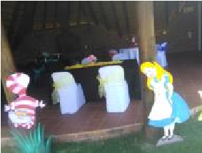 | Chair Covers  White or Black | R7 (plastic hole chairs)  R10 (round banquet) | 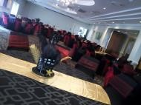 | Round table cloths | R55 (3m)  R45 (2,7m)  R35 (2,2m) | 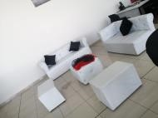 | Cushions  mixed sizes & colors | From R40
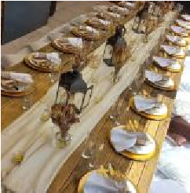 | Runners  variety of colors and options | R10-organza/hessian  R15-taffetta/glitter  R35-power mesh | 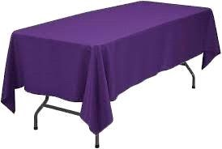 | Rectangle table cloths  variety of colors/options | R25 (standard  2,5mx1,5m) R35 (fitted)  R45 (full length - white) | 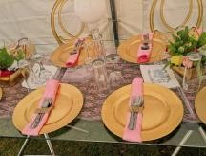 | Napkins variety of colors | R5
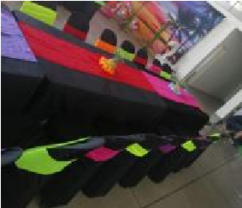 | Chair Tie backs  Variety of colors | R5- organza/hessian  R6- stretch bands | 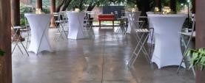 | Cocktail Table cloths | R45 Fitted R55 Loose | 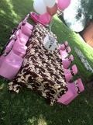 | Kids chair covers  Kids table cloths  Tie backs  Runners | R5  R12  R3,5  R5

Glasses, Crockery & Table wear (Items to be returned clean)
Product Image | Name | Price/Unit | Product Image | Name | Price/Unit | Product Image | Name | Price/Unit
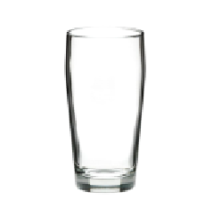 | Beer Glasses  Hi-Ball glasses  Zombie Glasses  Whiskey Tumblers | R2 |  | Dinner Plates | R3 | 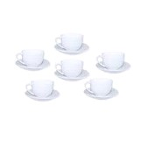 | Cup & Saucer set | R5
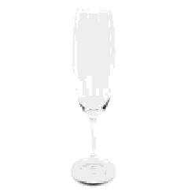 | Champagne Glasses  Wine Glasses | R2.5 | 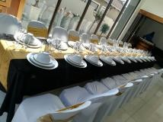 | Side Plates  Dessert Bowls | R2 | 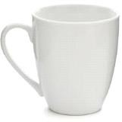 | Mug | R3
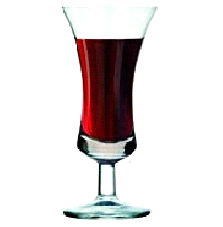 | Sherry/liquor glasses | R5 | 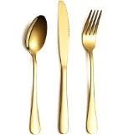 | Gold Cutlery  Knives, Forks  Dessert Spoons  Teaspoons  Cake forks | R2.5 | 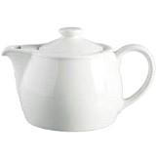 | Teapot  Milk jug  Sugar bowl | R15  R5  R8
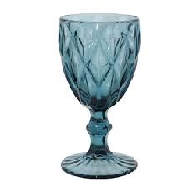 | Colored Goblet  Glasses | R8 | 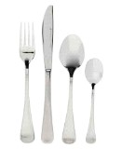 | Silver Cutlery  Knives, Forks  Dessert Spoons  Teaspoons  Cake forks | R1.5 | 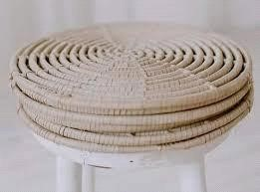 | Rattan Under plates | R8
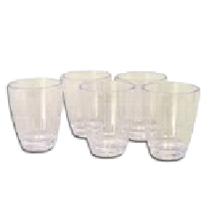 | Tot glasses | R1 | 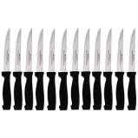 | Steak knives | R3 | 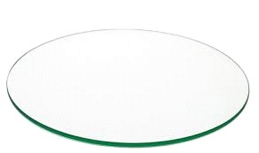 | Glass Under plate | R8
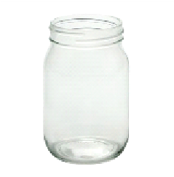 | Mason Jars | R2 - 350ml  R5 - 500ml | 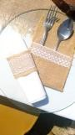 | Hessian napkin ring  Cutlery holder | R2  R5 | 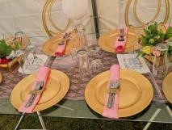 | Plastic Under plates silver or gold | R5
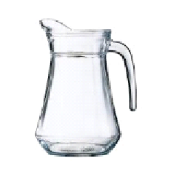 | 1,3L Jug | R10 | 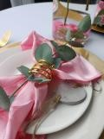 | Napkin Rings  Gold and silver | R5 | 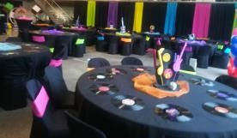 | LP Record Under plates | R5
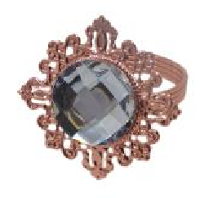 | Napkin Rings  Rose gold | R6

Catering & Serving Items (Items to be returned clean)
Product Image | Name | Price/Unit | Product Image | Name | Price/Unit | Product Image | Name | Price/Unit
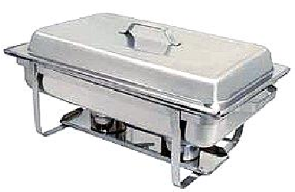 | Chaffing Dishes | R80  add fuel for R40 | 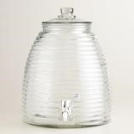 | 9L Juice Dispensers | R65 | 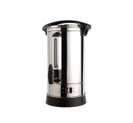 | Urn's | R80 - 16L  R100 - 30L
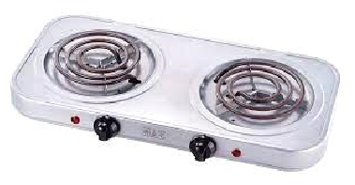 | Hot Plate | R50 | 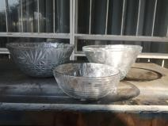 | Salad Bowls | R10-S  R20-M  R30-L | 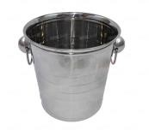 | Ice/Champagne bucket | R25
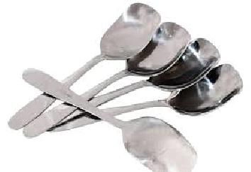 | Serving Spoon  Serving Fork | R6 | 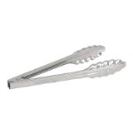 | Tongs- Serving  Tongs - Ice/sweets | R6  R5 | 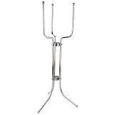 | Ice bucket stand | R50
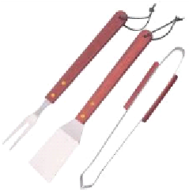 | Braai Set | R15 | 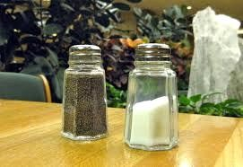 | Salt & Pepper set | R10 | 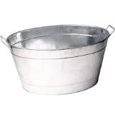 | Drinks Baths | R50
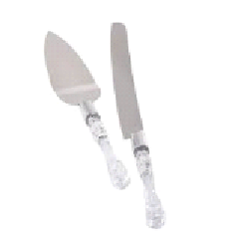 | Cake lifter set | R20 | 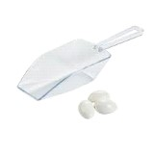 | Scoop | R5 | 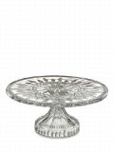 | Cake Stand | R50
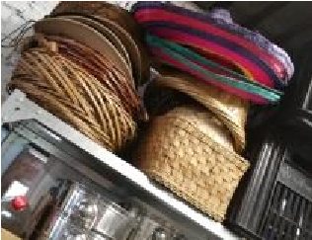 | Baskets | From R5 | 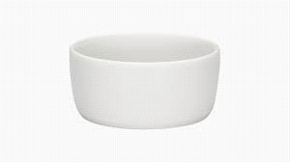 | Small butter dish | R2 | 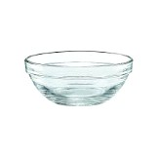 | Snack Bowl | R3
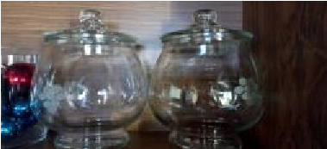 | Cookie jars | R40 | 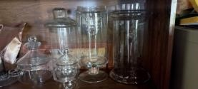 | Candy Jars | R15 - S  R30 - M  R50 - L  R75 - XXL

Vases, Candle holders & Lanterns
Product Image | Name | Price/Unit | Product Image | Name | Price/Unit | Product Image | Name | Price/Unit
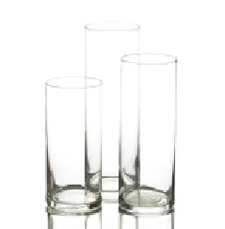 | Cylinder Vases | R45 - 30cm  R55 - 40cm  R65 - 50cm  R80 - 60cm | 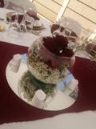 | Rose Bowl | R35 - 15cm  R5 - 8cm | 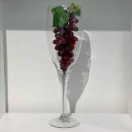 | Champagne Vase 40cm | R65
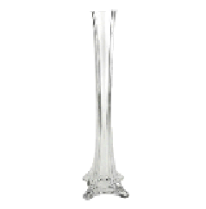 | Eifel Tower Vase | R40 - 20cm  R65 - 40cm | 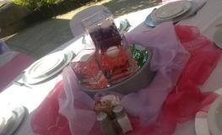 | Square/Rectangle Vases | R45-20cm rectangle  R35-15cm cube  R20 - 10cm cube  R15 - 8cm cube | 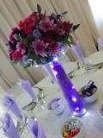 | Mushroom Vase 60cm | R80
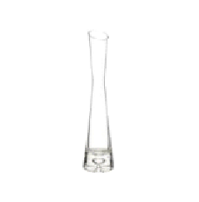 | Bud Vase 17cm | R8 | 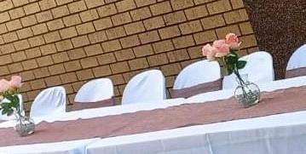 | Round bud vase 12cm | R8 | 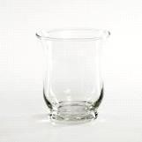 | Hurricane Vase 10cm | R5
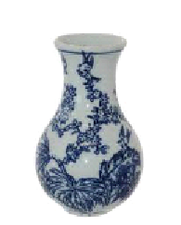 | Ginger Jar 14cm | R20 | 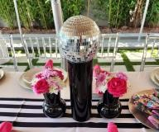 | Black Vases | R45 - 30cm cylinder  R35 - 15cm Adele | 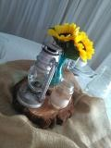 | Mini Teal Vases 15cm | R8
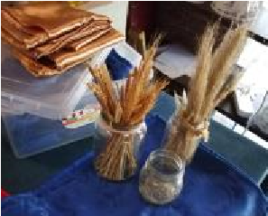 | Mason Jars add embellishments or wraps from R2 | R2 - 150- 350ml  R5 - 500ml | 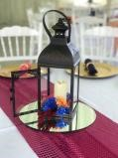 | Jasmin Lanterns  Cream & Hazel color | R80 | 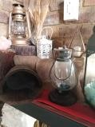 | Black Glass Lantern | R8
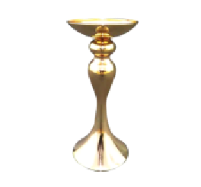 | Gold Candle Holder | R45 | 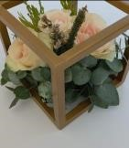 | Gold Cube | R30 | 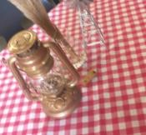 | Paraffin Lantern with fairy lights | R20
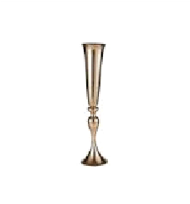 | Gold Trumpet Vase | R100 | 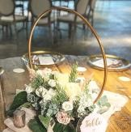 | Flower Ring | R25 | 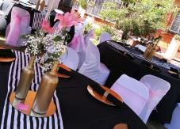 | Gold Wine bottle set of 3 | R15
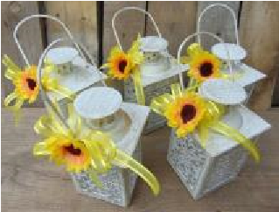 | Mini white lanterns | R8 | 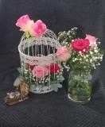 | Birdcages | R45 - 30cm  R25 - 65cm | 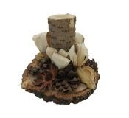 | Log candle holders | R3-S  R5-L
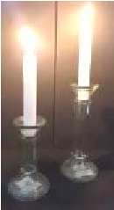 | Glass candle holder | R3-S  R5-M | 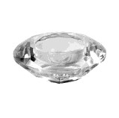 | Diamond Votive holder | R8 | 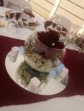 | Tea light Holders variety of designs | R3

 |  | Table Décor
Product Image | Name | Price/Unit | Product Image | Name | Price/Unit | Product Image | Name | Price/Unit
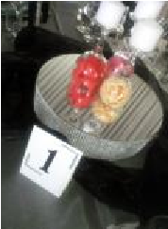 | Round Mirror Bases | R10 (20cm)  R20 (30cm)  R65 (60cm)  R20 for 30cm mirror raiser | 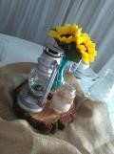 | Log Bases | R5 (8cm)  R8 (25cm) | 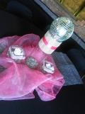 | Disco Balls | R5 (15cm)  R10 (20cm)
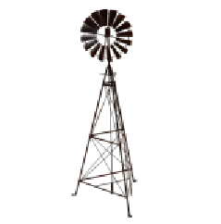 | Mini Windmills | R10 | 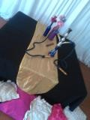 | Hubbly Bubbly | R45 | 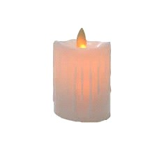 | LED Candles | R5 (tea light)  R10 (S- pillar)  R18 (M - Pillar)
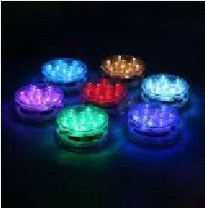 | LED Colored Lights | R30 | 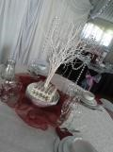 | White Trees | R25 | 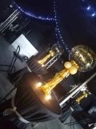 | Balloons | SQ
 | LED Numbers/Letters  20cm | R10 |  | Mr. & Mrs. Sign | R50
 |  | Custom Made Centerpieces and floral arrangements available on request
 |  | Lots and Lots of themed décor - Enquire about themed catalogues
 |  |  | Customizable Decor
Product Image | Name | Price/Unit | Product Image | Name | Price/Unit | Product Image | Name | Price/Unit
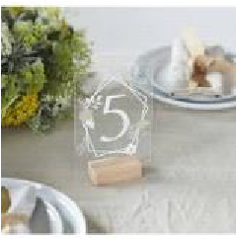 | Acrylic Table Numbers | R15 | 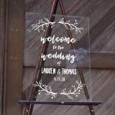 | Welcome Board 300mmx600mm  with design | R200 | 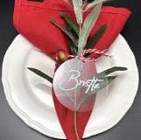 | Name Tags  (purchase item) | R15
 |  |  | Enquire to view our Personalized gifting
 |  |  | We custom create décor pieces for sale

